Generative AI(AD23633)

Project Title:

Mental health chatbot

Submitted by:

GUGAN M
231801046
AIDS

MENTAL HEALTH CHATBOT

ABSTRACT

Mental health support plays a vital role in a student’s and individual’s life, yet many people struggle to express their emotions or seek help due to stigma, lack of awareness, or limited access to resources. Traditional counseling methods are often timeconsuming, expensive, and not always available when immediate support is needed.
This project presents AI-powered mental health chatbot that provides emotional support and guidance based on user feelings and conversations. The system currently uses Machine Learning techniques such as Bag of Words and intent classification to identify user emotions like stress, sadness, or anxiety and respond accordingly with predefined supportive messages.
The chatbot not only interacts with users but also suggests coping mechanisms, relaxation techniques, and motivational guidance tailored to their situation. It can recommend simple mental wellness practices, daily habits, and actionable steps to improve emotional well-being. Additionally, conversational memory is implemented to maintain continuity, making the chatbot more interactive and engaging.
As a future enhancement, the system can be upgraded by integrating a Large Language Model (LLM) to generate more dynamic, human-like, and context-aware responses, thereby improving the overall intelligence.

INTRODUCTION

Mental health and emotional well-being are crucial aspects of a person’s life. However, many individuals struggle to express their feelings or seek help due to lack of awareness, social stigma, and limited access to support systems. With increasing academic pressure, personal challenges, and fast-paced lifestyles, emotional stress, anxiety, and loneliness have become more common, making timely support even more important.
Traditional counseling systems, while effective, may not always be accessible to everyone due to time constraints, cost, or availability of professionals. Additionally, many people hesitate to openly discuss their emotions, which creates a need for a safe, private, and easily accessible support system.
With advancements in Artificial Intelligence, especially in Natural Language Processing (NLP), intelligent systems can now understand user inputs and respond appropriately. Chatbots have emerged as an effective medium for interactive communication, offering immediate and continuous support.
This project aims to developan AI-based mental health chatbot that leverages:
- Machine Learning techniques for intent detection and emotion classification
- Rule-based responses for providing supportive and structured guidance
The chatbot acts as a virtual companion that understands user inputs and provides meaningful, empathetic, and personalized responses to support mental well-being. As a future enhancement, the system can be integrated with Large Language Models to enable more natural, dynamic, and context-aware conversations.

PROBLEM STATEMENT
Many individuals struggle to express their emotions and often lack immediate access to proper mental health support. People frequently rely on informal sources or suppress their feelings due to stigma, lack of awareness, or fear of judgment. Existing solutions do not always provide personalized or continuous support based on an individual’s emotional state and needs.
There is a need for an intelligent system that:
- Understands user input and identifies emotional states
- Provides supportive and empathetic responses
- Suggests coping strategies and mental wellness practices
- Maintains conversational context for meaningful interaction

OBJECTIVES
- To develop a chatbot that provides mental health support
- To analyze user emotions and input effectively
- To identify emotional states such as stress, sadness, or anxiety
- To suggest coping strategies and mental wellness practices
- To implement Machine Learning for intent detection and response generation
- To enable conversational interaction with basic memory for continuity
- To upgrade the system in future by integrating Large Language Models for more natural and intelligent responses

LITERATURE SURVEY
Mental health chatbots have gained significant attention in the field of Artificial Intelligence. Traditional chatbot systems often rely on rule-based approaches, where predefined responses are mapped to user inputs. However, such systems lack flexibility and are not capable of understanding varied or complex emotional expressions.
Machine Learning techniques such as intent classification and text processing methods like Bag of Words have been used to improve chatbot performance. These approaches help in identifying user emotions and generating appropriate responses based on trained data. Such models provide faster and more structured responses but may still have limitations in handling complex conversations.
Recent advancements in Artificial Intelligence, especially Large Language Models (LLMs), have significantly enhanced natural language understanding and response generation. LLMs are capable of producing human-like, context-aware replies, making chatbots more interactive and engaging.
However, relying entirely on LLMs may sometimes result in less controlled or inconsistent responses. Therefore, combining Machine Learning–based intent detection with LLM-based response generation can provide a more balanced, reliable, and efficient solution. In this project, the current system focuses on ML-based approaches, with future plans to integrate LLMs for improved conversational capabilities.

SYSTEM ARCHITECTURE
The system consists of multiple components working together:
User Input
↓
Preprocessing (Tokenization and Lemmatization)
↓
Feature Extraction (Bag of Words)
↓
Intent Classification (Machine Learning Model)
↓
Response Selection (Predefined Responses)
↓
Conversational Memory Handling
↓
Chatbot Output
Future Enhancement:
↓
Integration with Large Language Model (LLM) for advanced and human-like response generation

METHODOLOGY

1. Data Collection
A dataset containing conversational patterns and responses is created and extended using a mental health dataset. It includes:
- User input patterns (questions or emotional expressions)
- Corresponding chatbot responses
- Intent categories (e.g., greeting, stress, sadness, motivation)

2. Data Preprocessing
- Convert text to lowercase
- Remove unnecessary characters and spaces
- Tokenization and lemmatization using NLP techniques

3. Feature Extraction
Bag of Words (BoW) technique is used to convert textual data into numerical vectors for model training.

4. Model Training (Intent Classification)
A Machine Learning model is trained using the processed data to classify user input into predefined intent categories.

5. Response Selection
Based on the predicted intent, an appropriate response is selected from predefined responses stored in the dataset.

6. Conversational Flow Handling
Basic conversational memory is implemented to maintain interaction continuity and improve user experience.

7. Chatbot Interaction
The chatbot processes user input, predicts intent, and generates relevant responses in real time.

8. Future Enhancement
The system can be upgraded by integrating a Large Language Model (LLM) to generate more dynamic, human-like, and context-aware responses.

TECHNOLOGIES USED
- Python
- TensorFlow / Keras
- NLTK
- NumPy
- HTML, CSS, JavaScript (for frontend)

DATASET DESCRIPTION
The dataset contains conversational data for mental health support.
Fields:
- patterns (user inputs)
- responses (chatbot replies)
- tag (intent category)
Example:
"I feel stressed", "Take a deep breath and try to relax ", stress
IMPLEMENTATION
Modules
1. Data Module
- Loads and processes dataset using JSON and NLP tools

2. ML Module
- Bag of Words vectorization
- Intent classification using neural network
- Response Module
  - Matches predicted intent with predefined responses
- Backend
  - Handles chatbot logic and model inference

5. Frontend
- Simple chatbot interface for user interaction

IMPLEMENTATION SCREENSHOT

Code:
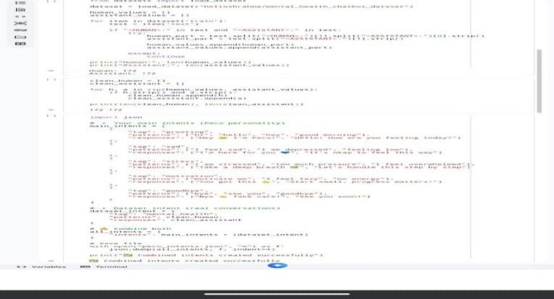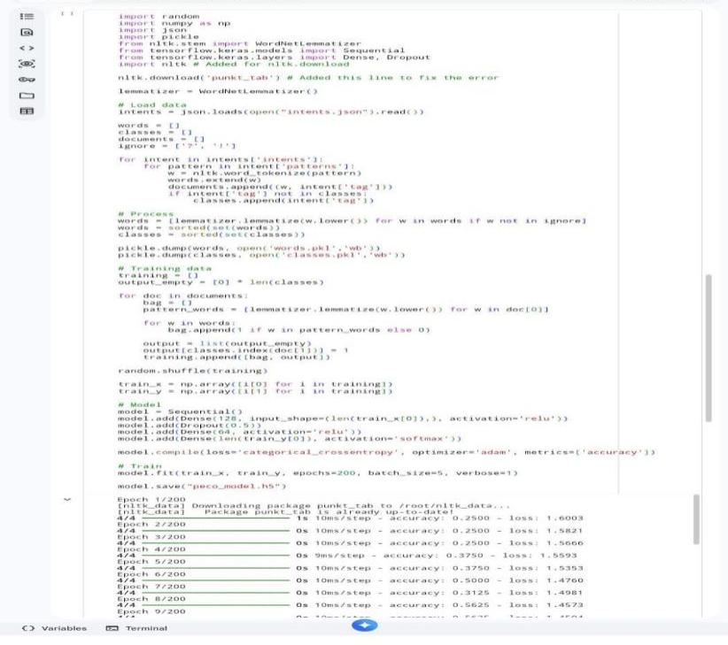
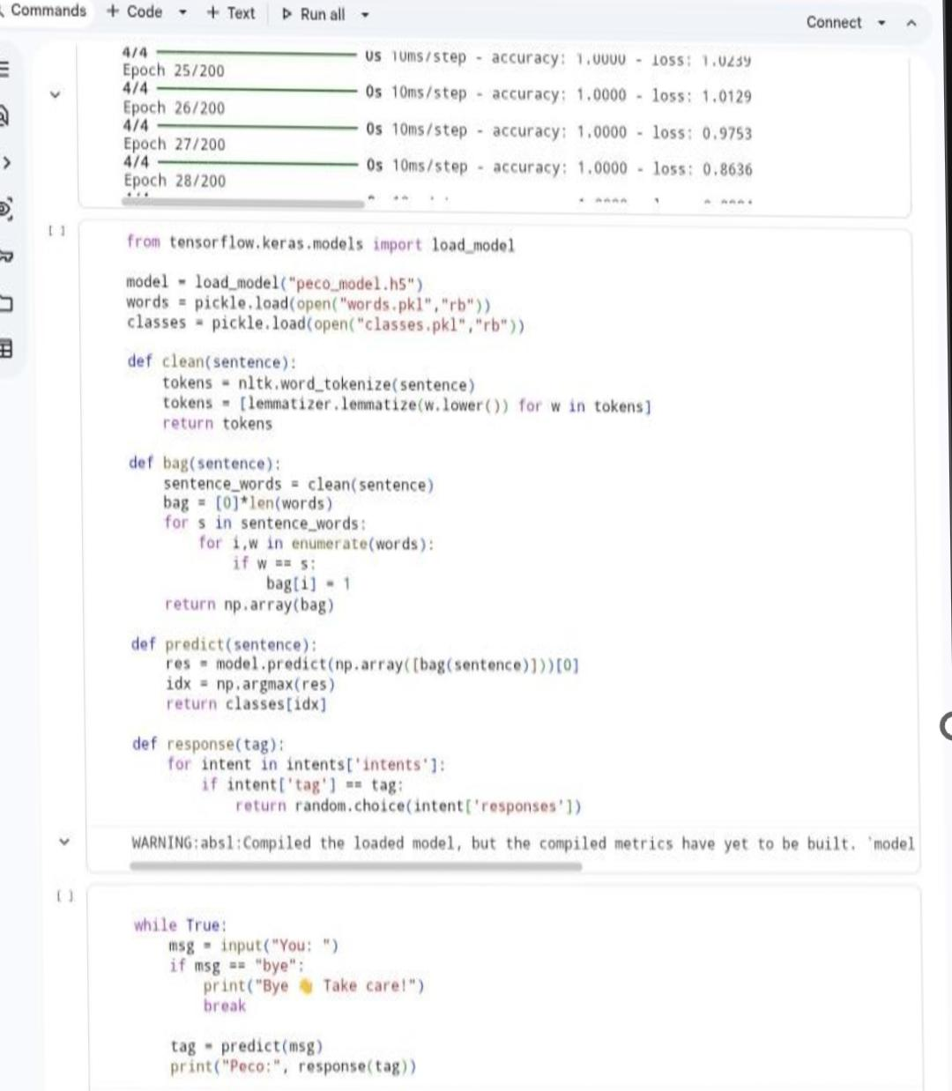

Data Set:

RESULTS AND OUTPUT
The chatbot successfully:
- Accepts user input
- Identifies user emotions and intent • Generates supportive and relevant responses
Example:
Input:
I feel stressed and tired
Output:
- Emotion Detected: Stress
- Response: Take a deep breath , you don’t have to handle everything at once
- Suggestion: Try a short break or a simple relaxation exercise

ADVANTAGES
- Provides personalized emotional support
- Interactive and user-friendly interface
- Uses Machine Learning for intent detection
- Easy to access and available anytime

LIMITATIONS
- Depends on the quality and size of the dataset
- Limited understanding of complex or unseen inputs
- Responses are predefined and may lack depth

FUTURE SCOPE
- Integration with Large Language Models (LLMs) for smarter responses
- Development of a mobile application
- Voice-based interaction for better user experience
- Advanced emotion detection using deep learning techniques

CONCLUSION
The chatbot successfully demonstrates how Machine Learning can be used to build an intelligent and interactive mental health support system. The chatbot is capable of understanding user input, identifying emotional states, and providing meaningful responses to assist users.
This project highlights the potential of AI in mental health support and shows how technology can make emotional assistance more accessible. With future enhancements such as LLM integration and advanced features, the system can become more powerful, adaptive, and human-like in its interactions.

